**IT DEPARTMENT PROCESS**

**DASHBOARD DESIGN & EMPLOYEE GRADE**

1. **Home Page Design**
2. **Form Design**
3. **Work Order Description**
4. **Table Name**
5. **Conditions**

**Work Order Year: 2018-19**

**No: INTERNAL Created By: Vinothini S**

**Kamatchi G**

**1. HOME PAGE DESIGN**

**1.1 DASHBOARD OLD VIEW:**

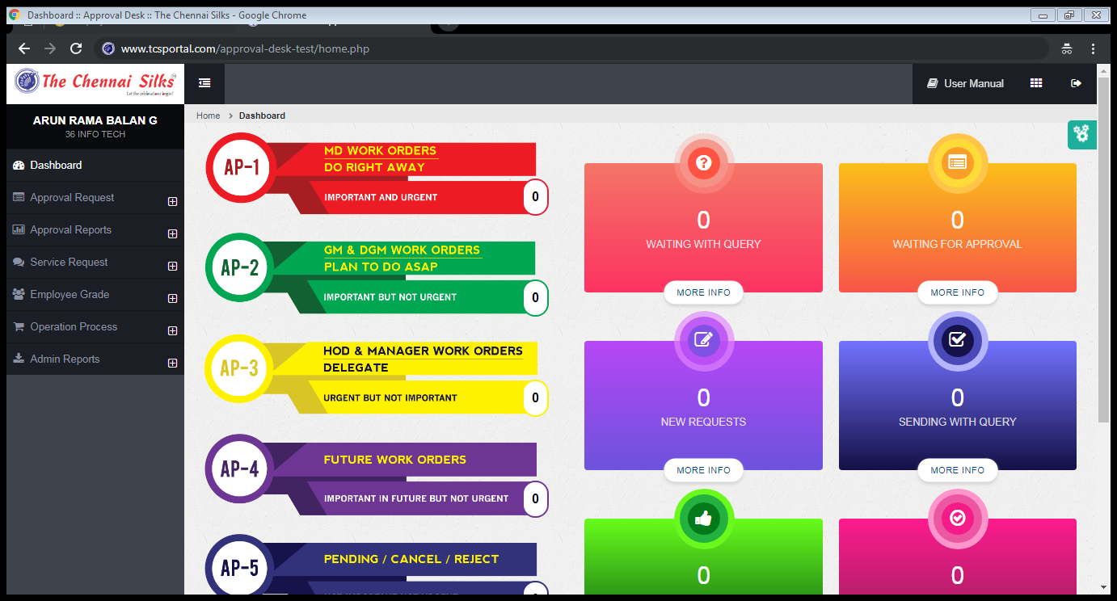

**1.2 DASHBOARD NEW VIEW:**

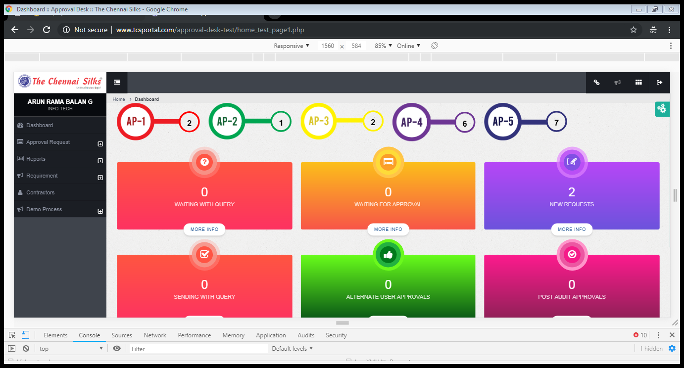

**2.EMPLOYEE GRADE REPORT**

**2.1 EMPLOYEE ADD PAGE:**

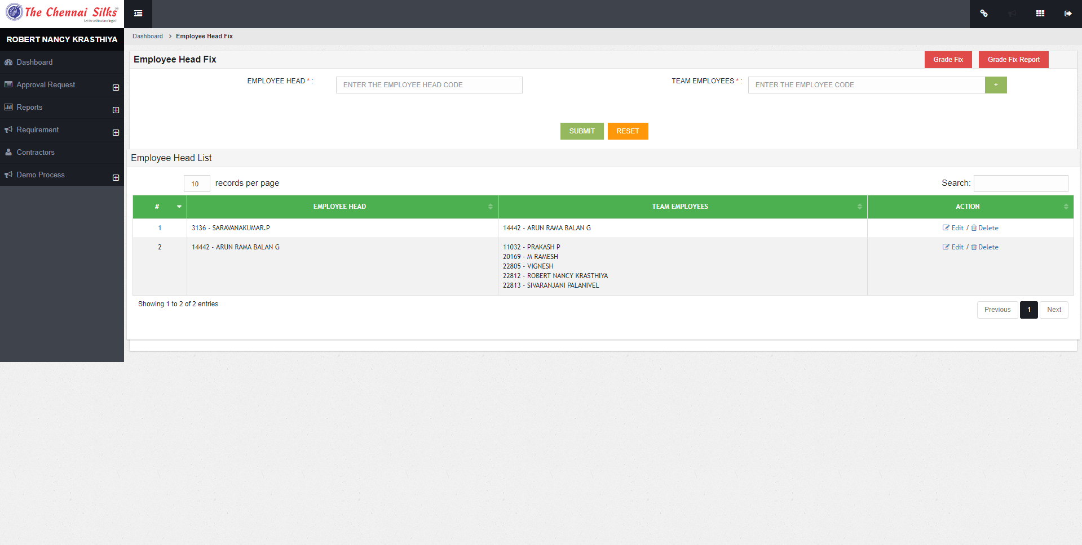

**2.2 EMPLOYEE GRADE WEEKLY REPORT:**

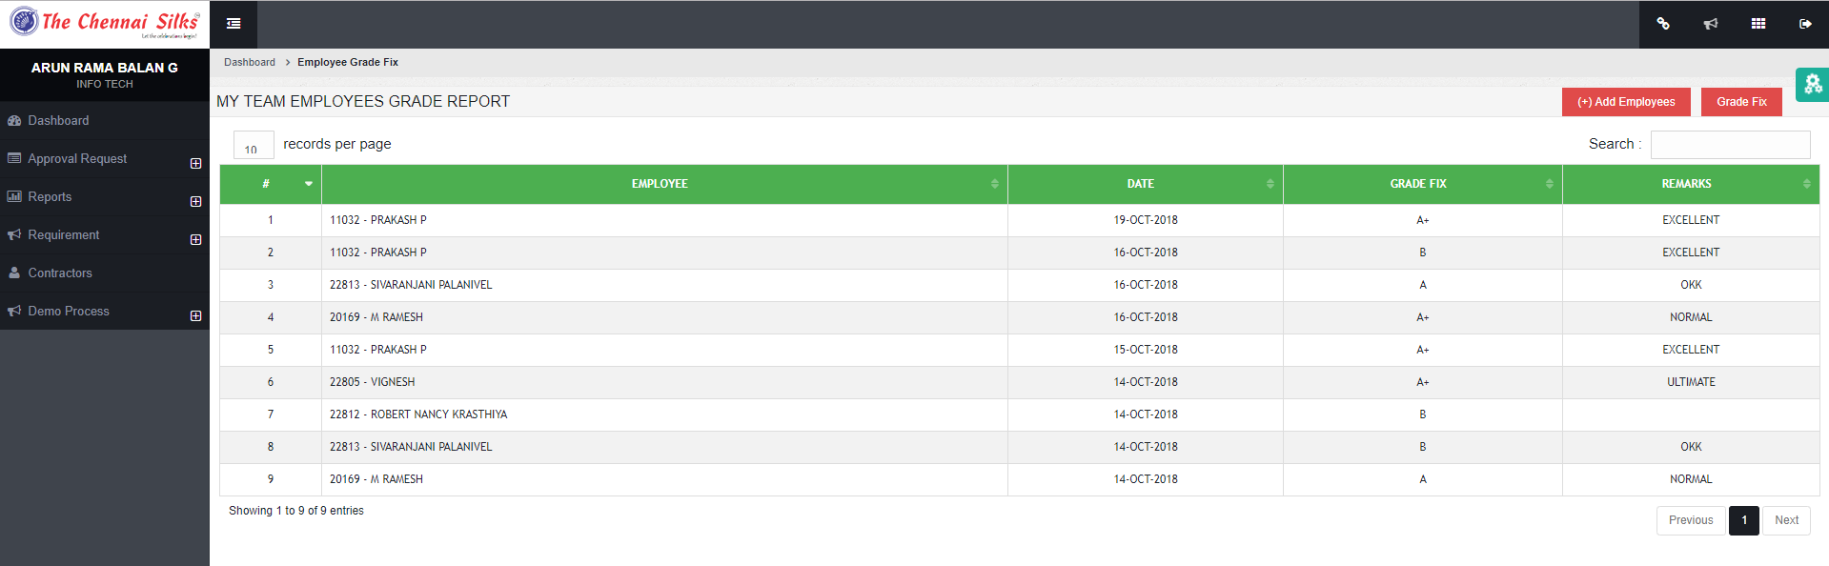

**2.3 EMPLOYEE GRADE MONTHLY REPORT:**

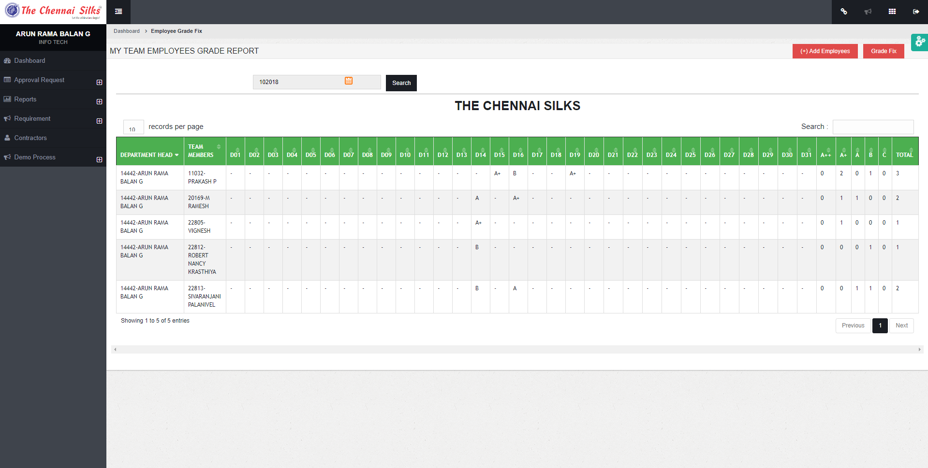

**3.DASHBOARD DESCRIPTION**

This process is edited the approval desk home page design. The column wise alignment is changed into the row. The old page images changed new design using the online Photoshop editor.

**4. EMPLOYEE GRADE PROCESS**

This page is used to see the employee grade report and remarks. The first page is used to add his employee name by the senior officer. And another page is used to provide the grade and remarks for that week. The last page will display the monthly report. If the officer want to edit the employee grade and remarks they can edit.

**TABLE NAME**

**4.1 Main Table:**

* Employee_Grade_Fix
* Employee_Head_user

**4.2 Reference Tables:**

* + - Branch
    - Employee_office

**5. CONDITIONS**

* + - 1. DELETED = ‘N’
      2. TIMRMOD = 1-Board timer
      3. TIMRMOD = 2- Manual Timer
      4. DELETED =’P’ –Timer Paused